NPR
Natural Pest Repellent
NPR offers products that use the Earth's magnetic field to provide natural benefits for Home, Health and Well-being.
What is NPR? NPR is a negative ion generator and life energy broadcaster. Both in a very small device.
NPR sucks Earth's magnetic field, gets filled with it, and starts pulsing it out as frequency close to human life frequency. Because it pulses so fast, during pulsing it filters negative ions in the air and fills the air around it with negative ions.
NPR and Pest Control:
NPR offers a natural method of pest control. No need to use unhealthy pesticides anymore. Here’s how this works. The frequency of human life is 176, which is good for us, our pets and our animals. Negative ions are the best anti oxidants that we can get which are good for us. But they are bad for any Pests that feed on death. Frequency of death is 0. Those pests have a frequency close to 25. Any frequency higher than 60 gives them very bad headache and negative ions make the air smells fresh, they don't like a fresh smell. They like stench. So when they are around NPR they run away.
NPR repels adult cockroaches, dust mites, bedbugs, ants, mosquitoes, black flies, spiders, and mice.
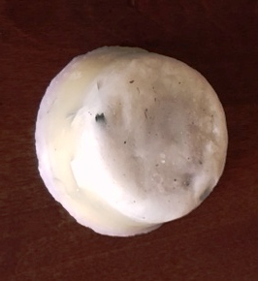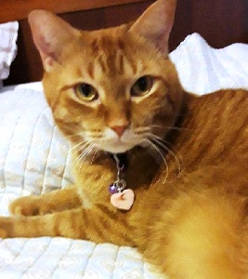
The "Muffin" - T$35 "Pet/SmallNecklace" - T$9
Place the small necklace on your cat or small dog to keep flees away.
Small necklace effect 3.5 sq. cubes area.
Medium size necklace effect 6 sq. cubes area.
Large necklace effect 9 sq. cubes area.
Place the "Muffin" in various rooms of your home to keep pests away. Put it on your patio to ward off mosquitoes, flies, and more. Covers approx. 4.5 sq. yards.
*See the Testimonials below about NPR for pest control and pets.
NPR Health Benefits:
NPR is a negative ion generator and life energy broadcaster. Negative ions are odorless, tasteless, and invisible molecules that we inhale in abundance in certain environments. Think mountains, waterfalls, and beaches. Once they reach our bloodstream, negative ions are believed to produce biochemical reactions that increase levels of the mood chemical serotonin, helping to alleviate depression, relieve stress, and boost our daytime energy in addition to repelling pests and insects, NPR has many health benefits.
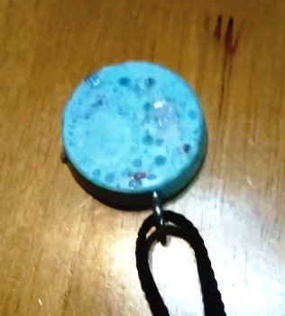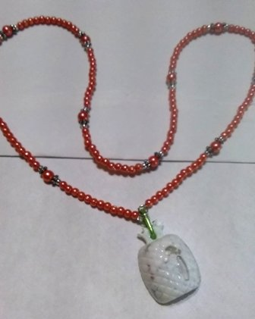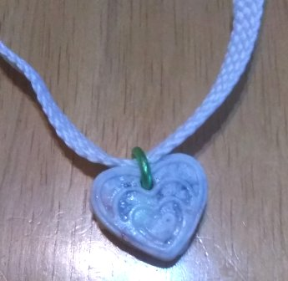
"Large Necklace" - T$18 "Medium Necklace" - T$15 "Small Necklace" - T$9
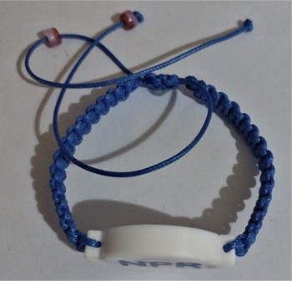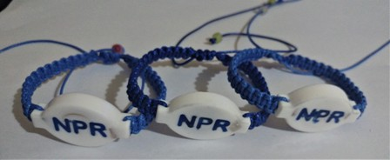
NPR “Bracelet” - $15
*See the Testimonials below about NPR and health benefits experienced.
We can buy a negative ion generator for thousands of dollars. But there is no life energy broadcaster out there. Life energy is called chi, prano, ruah; every culture calls it something different.
NPR gives Chi Energy to our body. Some benefits of Chi Energy are:
- Increased energy and vitality
- Deeper, more restful sleep
- Peaceful mind, a more positive attitude and better mood
- Increased flexibility and agility
- Better quality of life in old age
- Balance in breathing, heart rate, and blood pressure
- Reduced risk of inflammation
- Higher levels of energy
- Deep feeling of spirituality
- You might also notice more vivid dreams.
Healthier Skin Benefits
The skin provides a natural barrier to the environment thus absorbing the damaging effects of pollution. Because environmental pollution deprives our skin of pure oxygen we see an increase of stressed and pre-maturely aged skin resulting in fine lines and wrinkles with lack of firmness and elasticity.
NPR puts negative ions in our bloodstream. This makes our blood cells carry more oxygen to all over our body. This process has been shown to provide the benefits of a heightened level of concentration, alertness, and memory as well as offering a natural remedy for headaches, hangovers and jet lag. It is also said to be one of the most powerful and efficient methods of detoxifying the body and cleansing the blood. It also speeds muscle recovery after exertion.
Testimonials from some users of NPR products.
Testimonies about NPR use for natural pest control:
1. I couldn't even barbeque in the back porch. I am a magnet for misquitoes, they eat me alive. Ever since I put my NPR necklace on, mosquitoes don't touch me. Susan B. Evans, Ga
2. I bought the NPR muffin for my plants in the back. There was a wasp nest just above them by the roof. The next day I noticed the wasps were gone. Marcie B. Evans, Ga
3. I put NPR on my cat's collar. As she goes out often, she always got flees. I spent a fortune on chemicals, trying to keep her flee free. It is strange, but she doesn't have flees anymore on her after wearing the NPR fob around her neck. Martinez, Ga
Testimonies about NPR regarding health benefits they have experienced:
1. I have had a pain in my shoulder area for 5 years. After wearing NPR it was gone. Hanife C, Martinez, Ga
2. “I have to tell you that I have never felt better. I suffer from Lupus and Osteoarthritis. My feet are feeling wonderful and I am experiencing a feeling of "good" throughout the day. All of my coworkers are commenting on how wonderful I look. In fact, three of them also purchased NPR discs. Thank you so much.” Levittown, Pa
3. “I am now sleeping better after buying my NPR muffin." Lisa C, N. Augusta, Sc
4. “I was really shocked. I am 90 years of age and have had arthritis pain in my knees for many years. The day after buying NPR, I was able to work in my garden for hours without any arthritis pain. Doug A, Aiken, SC
5. "The only water my cat will drink is from the cup that sits on my NPR disc.. Mary A, Martinez, Ga
6. “Wearing my NPR necklace has greatly reduced the negative impacts of my ADHD. Instead of having millions of thoughts running through my mind, I can focus better at my job and have a much easier time doing my paper work. Also, I used to have rapid speech, but now I speak more slowly and concisely.” Manne E, Evans, Ga
7. “My menopausal symptoms, such as hot flashes and night sweats have disappeared. I sleep better throughout the night and notice more energy throughout the day. Thank you NPR!” Marcie E, Augusta, Ga
8. “I have worn my NPR necklace every day since buying it. Why should I take it off? After I started wearing this necklace, new friends started coming into my life telling me that I have “opened up” and so they got to know me and actually like me. One new friend admitted that she didn’t like me before, but now I seem much more balanced and approachable. Since I feel more confident and stable in the presence of people when I wear it, my life is unfolding in a whole new way. I am making friends and opening up to people in a delightful way I had never thought possible. I came back and bought 4 more NPRs to improve the ambiance in my home. I really love my NPR and am truly happy that they are protecting me from all the negative EMFs in the environment. I could go on and on but I’ll stop now.” Augusta, Ga

